FRACTALS-1

Benoit Mandelbrot:

The fractal geometry of nature. Macmillan, 1983.

"Clouds are not spheres, mountains are not cones, coastlines are not circles, and bark is not smooth, nor does lightning travel in a straight line.”

A fractal is a rough or fragmented geometric shape that can be subdivided into parts each of which is (at least approximately) a reduced-size copy of the whole (self-similarity). Dimension of fractals is generally non-integer.

Dimension:

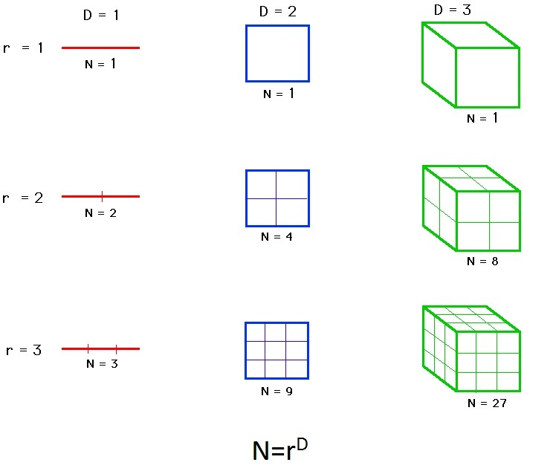

Deterministic Fractals

[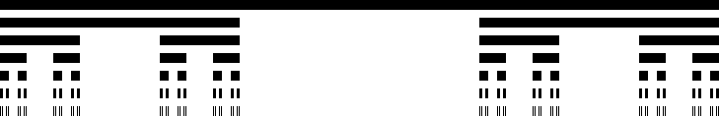](http://en.wikipedia.org/wiki/File:Cantor_set_in_seven_iterations.svg)

Cantor set: r=3, N=2, d= (log2)/(log3) = 0.6309

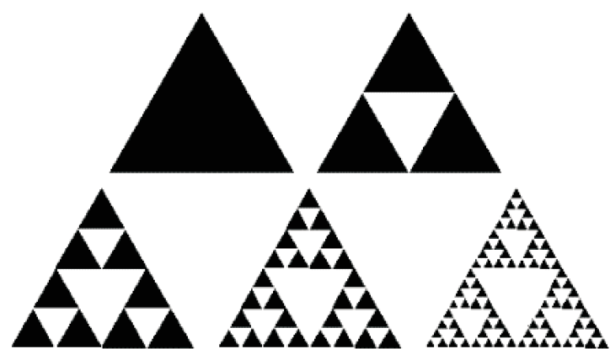

Sierpinski triangle: r=2, N=3, d = (log3)/(log2) = 1.5849

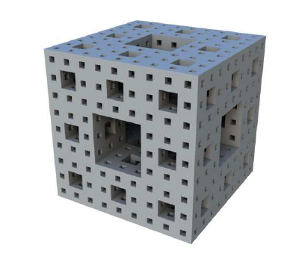

Menger sponge: r=3, N=20, d = (log20)/(log3) = 2.7268

Stochastic Fractals

[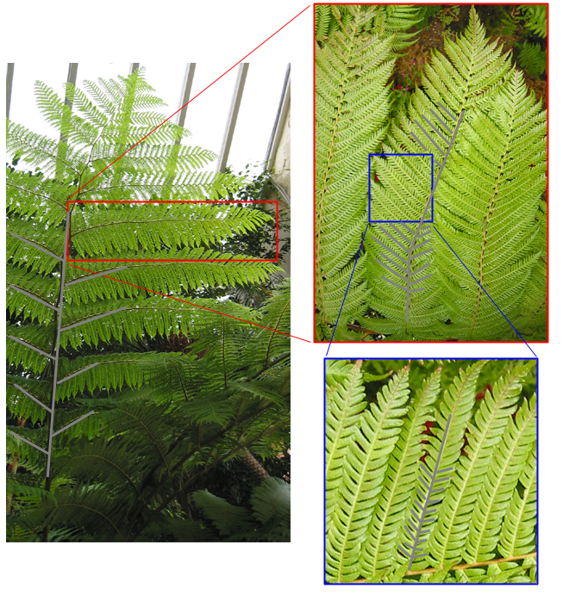](http://paulbourke.net/fractals/fracdim/)

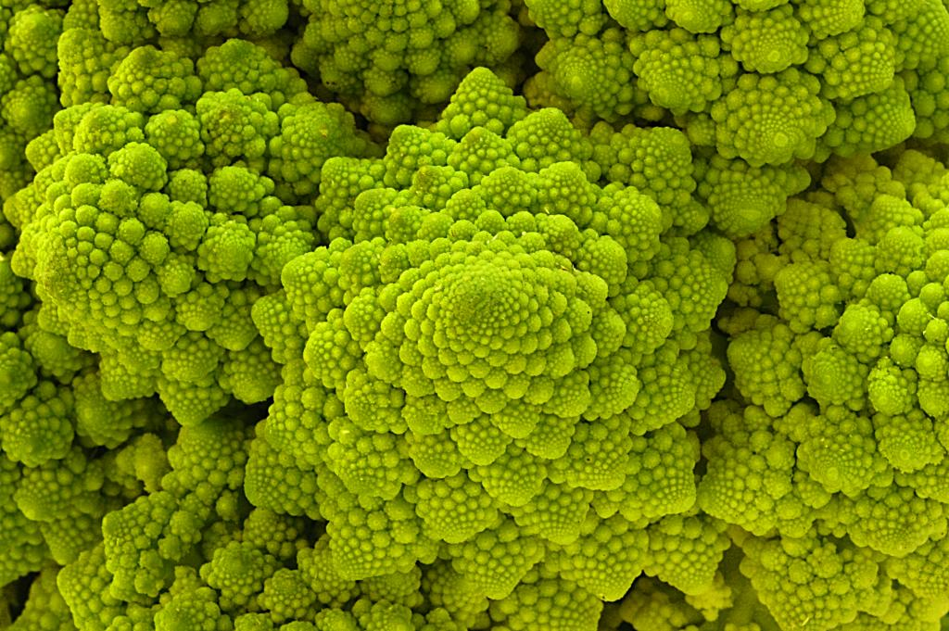

**Generalization of DLA:**

* Sticking probability p increases with the number n of neighbors seen by the walker when it finds the aggregate:
* For example, for α=0.1, n=2 sticking probability is 10 times smaller then for n=3, while for n=1 it is 100 times smaller the for n=3, and 10 times smaller then for n=2.

**Stochastic fractals: Diffusion Limited Aggregation**

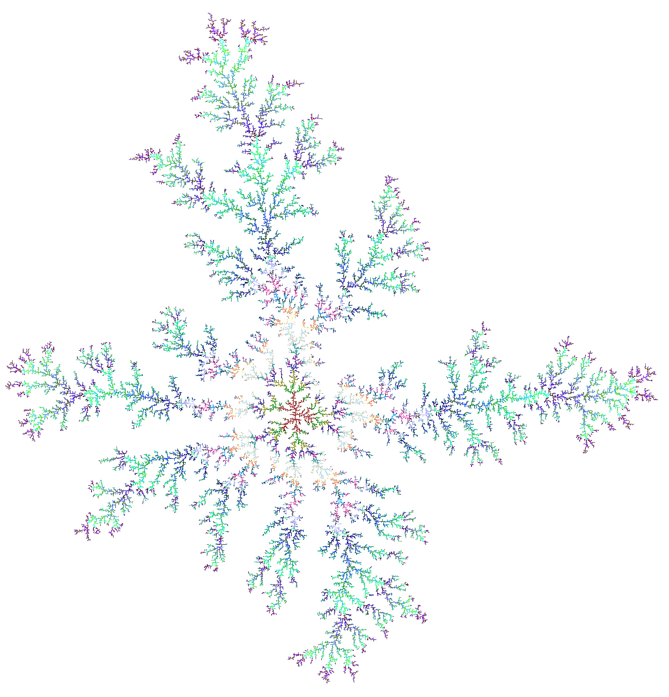

α=1.0

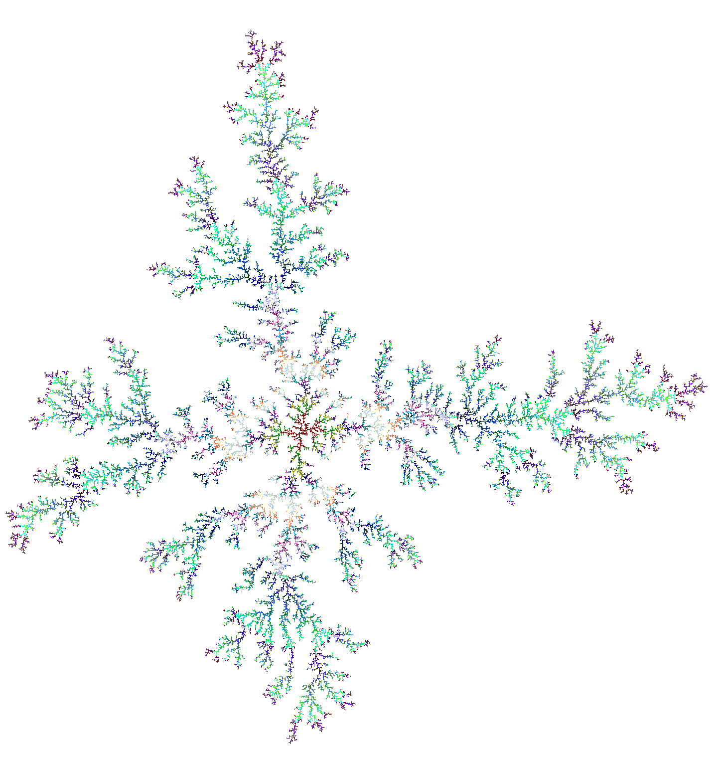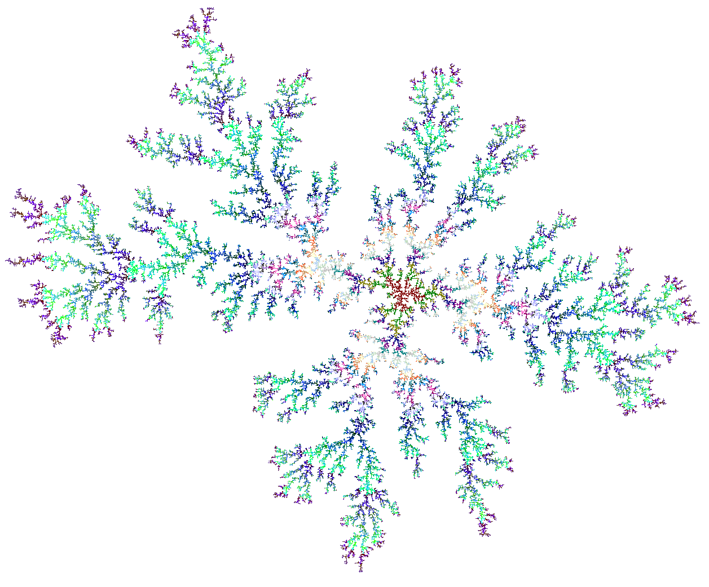

α=0.8

α=0.6

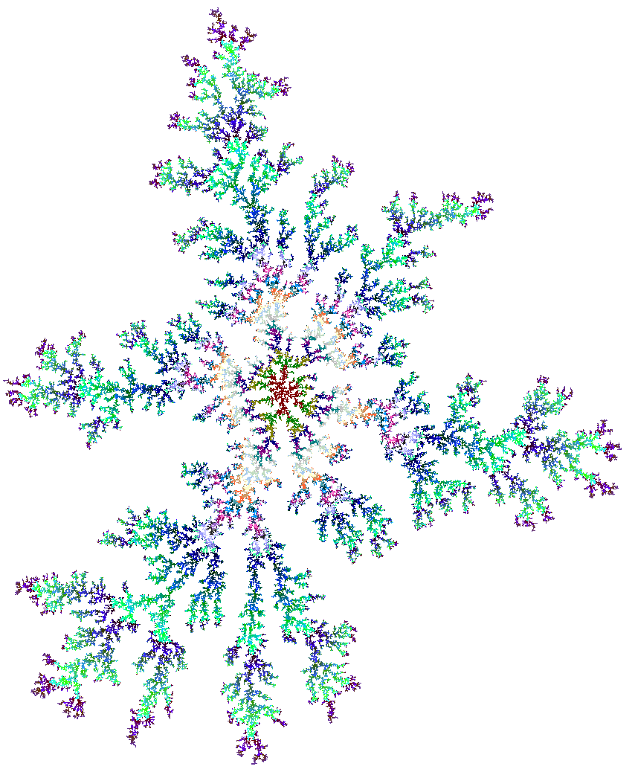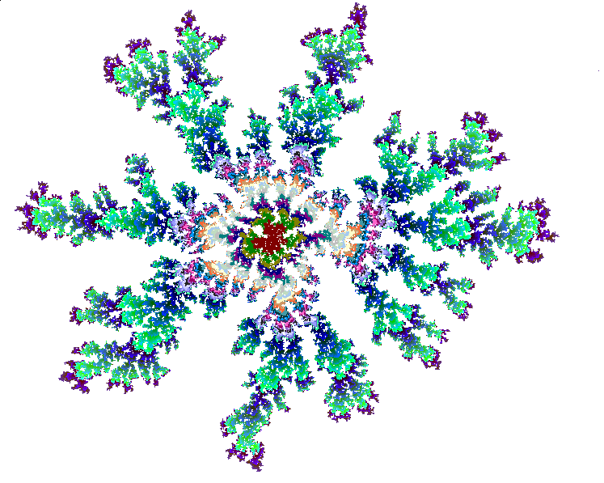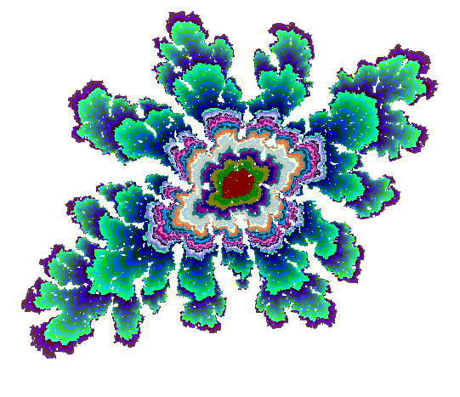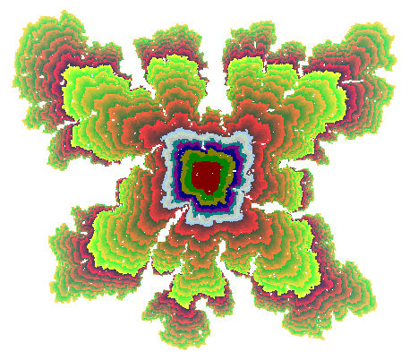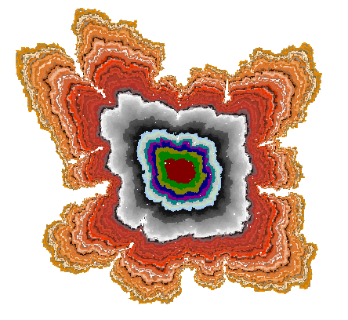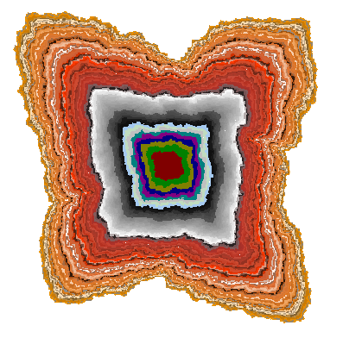

α=0.4

α=0.2

α=0.1

α=0.08

α=0.06

α=0.04

* Start from a seed
* Launch random walkers from a distant circle
* When the walker finds the cluster, it sticks (it turns )
* Launch another walker...

**Bibliography**

1. T.A. Witten and L.M. Sander, “Diffusion limited aggregation, a kinetic critical phenomena”, Phys.Rev. Lett. 47 (1981) 1400.
2. M. T. Batchelorand B. I. Henry, “Growth and form in the zero-noise limit of discrete Laplacian growth processes with inherent surface tension : I. The square lattice”, Physica A 187 (1992) 551.

n=3, p=1

n=2, p=α

n=1, p=α2